**Sprint 3 Plan**

Summarize Everything

Summarize Everything

End: Feb. 22, 2022

Revision: 2

Revision Date: Feb. 18, 2022

**Goal:**

Complete front-end styling and add more polish to all components of the service, including more training, optimization and adding generalized parsing from HTML.

**Task listing (Organized by user story):**

*User story 1:* As a developer, I would like to have qualitative performance metrics (test inputs) that will allow us to select our best performing model (13 points)

*Task 1:* Choose a set of inputs which represent expected inputs. (2 hours)

*Task 2:* Calculate a metric to determine the quality of the resulting summaries. (4 hour)

Task 3: Create datasets without mix bias (5 hours)

Task 4: Add debugging tools, logging, and training metrics information (2 hours)

*User story 2:* As a user, I would like to be able to get summaries that take longer than http timeouts would typically enable (13 points)

*Task 1:* Incorporate sockets into the current frontend and backend. (3 hours)

*Task 2:* Migrate to a host which supports sockets. (6 hours)

Task 3: Explore scalable infrastructure (2 hours)

*User story 3:* As a user, I would like to be able to input a URL and allow the service to automatically extract useful information from the website. (8 points)

*Task 1:* Allow space on web page to enter URLs. (1 hour)

*Task 2*: Figure out how to get the article text avoiding unnecessary

ads/popups/etc. (8 hours)

*User story 4:* As a user, I would like to have an interface that works intuitively and provides me information about my input text and the resulting summary. (8 points)

*Task 1:* Prevent multiple simultaneous queries. (2 hours)

*Task 2:* Verify models returned by the API are valid. (1 hour)

*Task 3:* Hide the summarization query button when editing text. (0.5 hours)

*Task 4:* Acknowledge that a query has been sent. (1 hour)

*Task 5:* Fix issues with the character counter. (0.5 hours)

*Task 6:* Add a new section for alerts for the summary. (1 hour)

*Task 7:* Add a scroll bar to the summary text if it becomes too long. (1 hour)

**Team Roles:**

Jess Fan: Project Owner, Developer

Pushu Zhang: Developer

Janet Zhu: Developer

Sebastian Medina: Developer

Victor Ho: Scrum Master, Developer

**Initial task assignment:**

Jess Fan:

*User Story* - Story 2

*Initial Task* - Migrate to a host which supports sockets.

Pushu Zhang:

*User Story* -

*Initial Task* -

Janet Zhu:

*User Story* - Story 1

*Initial Task* -   
Sebastian Medina:

*User Story* - Story 3

*Initial Task* - 3.1, 3.2

Victor Ho:

*User Story* - Story 3

*Initial Task* - 3.2

**Initial burnup chart:**

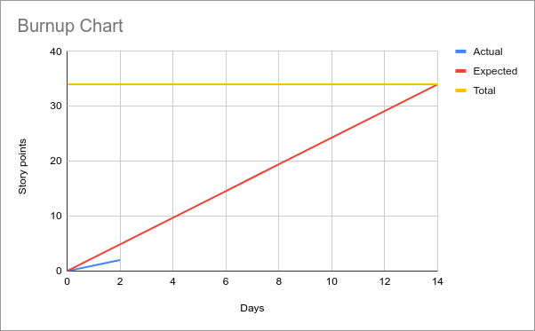

**Initial scrum board:**

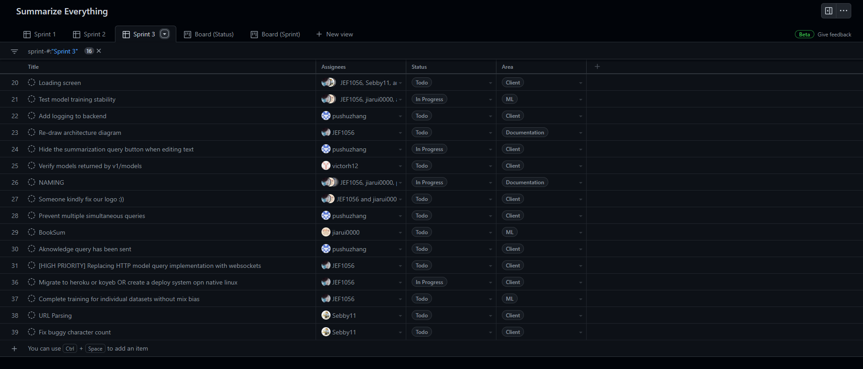

**Scrum times:**

* Monday: 8pm - 9pm
* Wednesday: 8pm - 9pm
* Friday: 3pm - 4:30pm [**TA meeting** 3pm - 4pm]